Subject: 20CS2036L – Web Technology Lab

Lab Exercise: 3. Design a Webpage using HTML and CSS (Duration: 1.30 hours)

**Create a webpage for user profile using proper HTML5 and CSS3. Page should have header, section and footer.**

1. **In header**

a. Add your profile photo and display your name using ‘display’ property. Align the text at the center. Set the font size: 48px and add text shadow effect.

1. **In section**
2. Add a **banner image** and display the text over the banner image in left center.
3. Add four **thumbnails** below the banner, each of the 4 sections should take up equal amount of space on the screen. As you make the browser window wider or narrower, each section should become wider or narrower. (Hint: use percentages to define width and use the ‘display’ property. Note the spacing between the images. Note the horizontal spacing between the edges of the images and edges of the browser window. Each thumbnail has a caption box that is positioned at the bottom. Set the background color to the boxes and the background color still allows the user to view the images and display the clickable menu items.
4. Include DIV Section for About You
5. Add a section which contains an image and text content side by side (vice versa). Use “opacity” and “float” wherever it is necessary.
6. Borders and Colors: Each section should have a background color set to some color (of your Choice). Set the background color of each section title region to some unique color. Depending on the color you choose, you may want to change the color of the text so it can be easy to read. Set a red border on section title region that is 2px thick. (Hint: use margins and padding and use border-box as your box-sizing).
7. **In footer** display the contact details. Set the suitable background color and text color. Set font style: italic and align the text at center.
8. Your page must contain internal CSS code using <style> tag and inline styles (minimal numbers) and do not use External Style Sheet (will do it Exercise 4).
9. Use the mockup illustration page given below. Your result should look very close to the mockup.
10. Publish your website live on the web using some free web hosting services (000webhost)

**PROGRAM :**

<!DOCTYPE html>

<html lang="en">

<head>

<meta charset="UTF-8">

<meta name="viewport" content="width=device-width, initial-scale=1.0">

<title>Ex 3</title>

<link rel="icon" type="image/x-icon" href="fav.jpg">

<style>

*{

margin: 0px; padding:0px;

box-sizing: border-box;

}

.headf1{

background-color: rgb(33, 165, 202); height: 100px;

text-align: center;

}

img{

width: 100px; height: 100px; position: absolute; left: 0px;

}

#text{

font-size: 48px; text-align: center; top: 50px; position: relative;

text-shadow: 5px 5px gray;

}

.headf2{

background-image: url('image.jpg'); height: 250px;

background-size: cover; position: relative;

}

.f2{

border: 5px dashed black; border-left: 5px dotted; height: 250px;

width: 250px;

background-color:rgb(221, 107, 54); text-align: justify;

padding: 20px; position: relative; left: 50px;

}

.sec2 {

position: relative; display: flex;

justify-content: space-between; background-color: rgb(255, 83, 255);

}

.col {

flex: 0.5; margin: 10px;

position: relative;

}

.image{

position: relative; width: 100%;

height: 100%; object-fit: cover;

background-color: #1a6b4c;

}

.txts {

position: absolute; bottom: 0;

background: rgba(0, 0, 0, 0.5); color: #fff;

width: 100%; padding: 10px; border: 2px solid red; text-align: center;

}

.sec4 {

position: relative;

background-color: rgb(10, 239, 204);

border: 5px rgb(25, 161, 159);

}

.sec4 .content4 img{ position: relative; float: right; width: 250px; height: auto;

}

.sec4 h3 p{ height:250px; position: absolute; text-align: justify;

}

.f5{

background-color:rgb(25, 84, 113); height: 250px;

}

.f55{

text-align: left; font-size: 30px;

}

.f555{

text-align:justify; position: absolute;

}

.f5i{

position: absolute;

float: right; height: 250px; width: 250px; right: 0px;

}

.f6{

background-color:rgb(87, 213, 148); height: 200px;

}

.f66{

text-align: center; font-size: 30px; color: red;

text-decoration: underline; position: relative; top:50px;

}

.f666{

font-size: 22px; font-style: italic; text-align: center; position: relative; top:64px;

}

</style>

</head>

<body>

<header>

<div class="headf1">

<img src="bk.jpg" alt="our_logo">

<div id="text">BHARATH KUMAR S</div>

</div>

</header>

<div class="headf2">

<div class="f2">Hello, I'm Bharath Kumar S, and I'm passionate about generative AI and data science. Currently pursuing my studies as an AI Engineer at Karunya University, I have a solid foundation in classical machine learning algorithms and am now eager to explore the depths of deep learning. </div>

<div class="sec2">

<div class="col">

<img class="image" src="html.png" alt="Image 1">

<div class="txts">HTML</div>

</div>

<div class="col">

<img class="image" src="css.png" alt="Image 2">

<div class="txts">CSS</div>

</div>

<div class="col">

<img class="image" src="js.jpg" alt="Image 3">

<div class="txts">JAVA SCRIPT</div>

</div>

<div class="col">

<img class="image" src="php.jpg" alt="Image 4">

<div class="txts">PHP</div>

</div>

</div>

<div class="f4">

<div class="f44"><b>About You</b></div>

<div class="f444">Hey everyone, I'm Bharath Kumar, and I'm excited to share my journey in the field of Artificial Intelligence and Data Science. I'm currently studying at KITS Coimbatore, Bhopal, and I'm also a member of the Google Developers Group cloud kochi. I have a strong foundation in AI and programming languages such as Python, R, and SQL.

I'm known for my enthusiasm in the field of AI, and I'm soon to be a graduate with an MSc. in Artificial Intelligence from Brunel University London. My passion for AI and programming is evident from my active involvement in various AI and coding projects, reflecting my commitment to continuous learning and skill development.

I'm proficient in both Data Science and Software Development, and I have experience in back-end development using Python, Pandas, Redshift DB, and Jupyter. I'm also an AI Developer, Web Developer, and BlockChain Enthusiast. I'm excited to continue learning and growing in this field, and I'm always open to new opportunities and collaborations.

</div>

</div>

<div class="sec4">

<div class="content4"><h3>Your Intersets</h3>

<img src="ai.jpeg" alt="Group Pics">

<p>Artificial Intelligence:

Hey everyone, I'm Bharath Kumar, and I'm excited to share my journey in the field of Artificial Intelligence and Data Science. I'm currently studying at KITS Coimbatore, Bhopal, and I'm also a member of the Google Developers Group cloud kochi. My passion for AI ignited during my undergraduate studies, where I was captivated by its potential to revolutionize various industries. This drove me to pursue a deeper understanding of AI and its applications.

My academic journey has equipped me with a strong foundation in AI and programming languages such as Python, R, and SQL. I've delved into courses ranging from machine learning to natural language processing, honing my skills through practical projects and research endeavors.

One of the highlights of my academic journey is my upcoming graduation with an MSc. in Artificial Intelligence from Brunel University London. This experience has not only deepened my theoretical knowledge but also provided me with invaluable practical insights through industry collaborations and internships.

Throughout my academic and professional journey, I've been known for my enthusiasm and dedication in the field of AI. I've actively contributed to various AI and coding projects, leveraging my expertise to develop innovative solutions. Whether it's developing AI-driven applications or optimizing algorithms for performance, I'm committed to pushing the boundaries of what's possible in AI.

In addition to my proficiency in Data Science and Software Development, I have hands-on experience in back-end development using Python, Pandas, Redshift DB, and Jupyter. This diverse skill set has enabled me to tackle complex challenges and deliver impactful results across different domains.

Beyond technical skills, I'm also passionate about fostering collaboration and knowledge sharing within the AI community. As an AI Developer, Web Developer, and Blockchain Enthusiast, I've actively participated in meetups, hackathons, and conferences, connecting with fellow enthusiasts and contributing to the collective advancement of AI. </p>

</div>

</div>

<div class="f6">

<div class="f66"><b>Address</b></div>

<div class="f666">Door No:177/52, Anna St,Mayiladuthurai Dt <br>TamilNadu-609001,India.</div>

</div>

</body>

</html>

# OUTPUT:

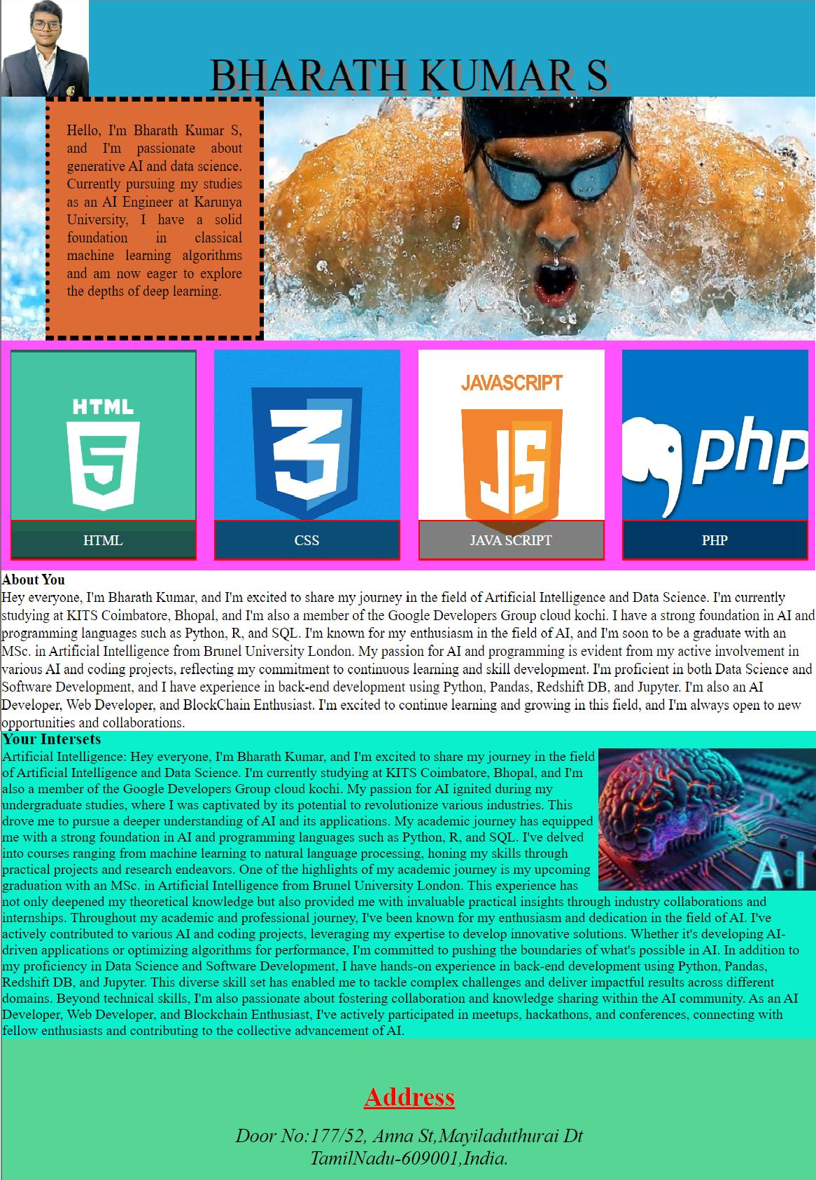

**RESULT :**

webpage for user profile using proper HTML5 and CSS3. Page should have header,section and footer. Therefore, I created a webpage by working with HTML5 and CSS3 and executed it successfully